**Project Design Phase-II**

**Data Flow Diagram & User Stories**

|  |  |
| --- | --- |
| Date | 6 March 2025 |
| Team ID | SWTID1741328989146361 |
| Project Name | Cook Book |
| Maximum Marks | 4 Marks |

**Data Flow Diagrams:**

A Data Flow Diagram (DFD) is a traditional visual representation of the information flows within a system. A neat and clear DFD can depict the right amount of the system requirement graphically. It shows how data enters and leaves the system, what changes the information, and where data is stored.

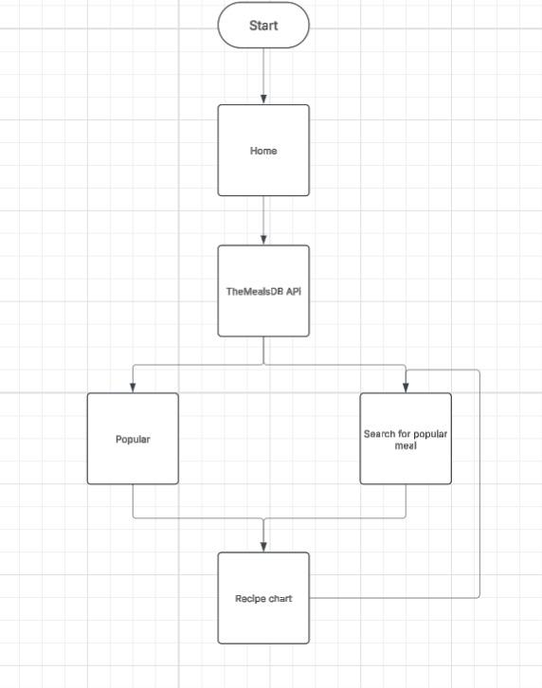

**User Stories**

| **User Type** | **User Story Number** | **User Story / Task** | **Acceptance criteria** | **Priority** | **Release** |
| --- | --- | --- | --- | --- | --- |
| Customer  (Web user) | USN-1 | As a user, I can search for recipes, view detailed recipe instructions | I can access my account / dashboard | High | Sprint-1 |
| Customer  (Web user) | USN-2 | As a user, I can view details about Indian food | I can view details of recipes | High | Sprint-1 |
| Customer  (Web user) | USN-3 | As a user, I can view information about all kinds of recipes | I can view information about all kinds | Low | Sprint-2 |